/*
Q1) Write a program that uses a class where the member functions are defined
outside a class
*/
#include<iostream>
using namespace std;
class add
{
public:
int a,b;
int sum(int a,int b);
};

int add::sum(int a, int b)
{
return a+b;
}

int main()
{
add obj;
cout<<"enter numbers ::";
cin>>obj.a>>obj.b;

cout<<"Sum of two number is : "<< obj.sum(obj.a,obj.b);
}

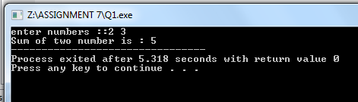

/*
Q2) i)Write a program that uses a class where the member functions are defined
outside a class
ii)Try with local objects
*/
#include <iostream>
using namespace std;

void sum()
{
class add // local object
{
public:
int a,b;
int method(int a,int b)
{

return a+b;
}
};

add t;
cout<<"Enter numbers";
cin>>t.a>>t.b;
cout<<"The sum is : "<<t.method(t.a,t.b);
}

int main()
{
sum();
return 0;
}

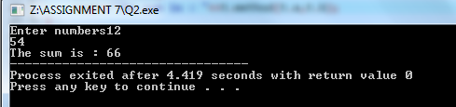

/*
Q5-i) Write a program in c++ to convert a decimal number into binary without using
an array and using constructor and destructor
*/

//Using CONSTRUCTOR
#include <iostream>
using namespace std;
class Decimal_Number
{
public:
Decimal_Number(int n)
{
int i=1,j=n,Binary_Number=0;
cout<<"Please enter Decimal number : ";
cin>>n;
for(j=n;j>0;j=j/2)
{
Binary_Number=Binary_Number+(n%2)*i;
i=i*10;
n=n/2;
}
cout<<"binary number ="<<Binary_Number;
}
};
int main()
{
Decimal_Number obj(4);

}

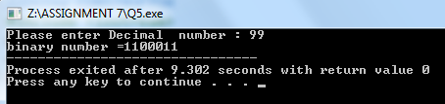

/*
Q5-ii) Write a program in c++ to convert a decimal number into binary without using
an array and using constructor and destructor
*/

//Using DESTRUCTOR
#include <iostream>
using namespace std;
class Decimal_Number
{
public:
Decimal_Number(int n)
{
int i=1,j=n, Binary_Number=0;
cout<<" Please enter Decimal number :";
cin>>n;
for(j=n;j>0;j=j/2)
{
Binary_Number=Binary_Number+(n%2)*i;
i=i*10;
n=n/2;
}
cout<<"binary number ="<<Binary_Number<<endl;
}
~Decimal_Number()
{
cout<<"Destructor run , FREE MEMORY "<<endl;
}
};
int main()
{
Decimal_Number obj(4);
}
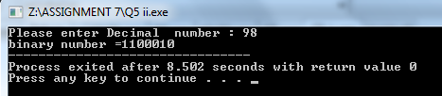

/*
Q6) write a progrm in c++ to print Floyd's Triangle
by using the constructor and destructor
*/
#include<iostream>
using namespace std;
class Floyds_Triangle
{
public:
int i,j,p,q,n;
public:
//constructor
Floyds_Triangle() {
cout<<"Please enter the no of rows";
cin>>n;
for(i=1;i<=n;i++)
{
if(i%2==0)
{
p=1;
q=0;
}
else
{
p=0;
q=1;
}
for(j=1;j<=i;j++)
{
if(j%2==0)
{
cout<<p;
}
else
{
cout<<q;
}
}
cout<<endl;
}
}
~Floyds_Triangle() // destructor
{
}
};
int main()
{
Floyds_Triangle object;
return 0;
}

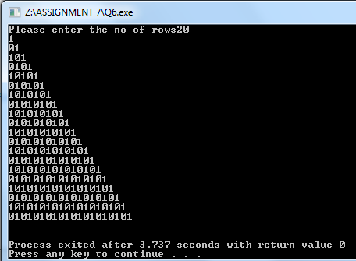

/*
Q7) Let's see the c++ program to show the Sum of n numbers of odd natural
numbers by using the different type of constructors
*/
#include<iostream>
using namespace std;
class Sum_Constructor_Overloading
{
private :
int i,n,number1 ,number2;
public :
Sum_Constructor_Overloading(int a)
{
n=a;
int sum=0;
for(int i=1;i<=n;i++)
{
cout<<"The output is:"<<endl;
cout<<2*i-1<<" ";
sum=sum+(2*i-1);
cout<<endl;
}
cout<<"The sum of the given input = "<<sum<<endl;
}

Sum_Constructor_Overloading(int two,int three)
{
cout<<"For 1st Input Answer is Given below"<<endl;
number1 =two;
int sum1=0;
for(int i=1;i<=number1 ;i++)
{
cout<<"The output is:";
cout<<2*i-1<<" ";
sum1=sum1+(2*i-1);
cout<<endl;
}
cout<<"The sum of the given input = "<<sum1<<endl;
cout<<endl;
cout<<"For 2nd Input Answer is Given below."<<endl;
number2=three;
int sum2=0;
for(int i=1;i<=number2;i++)
{
cout<<"The output is:";
cout<<2*i-1<<" ";
sum2=sum2+(2*i-1);
cout<<endl;
}
cout<<"The sum of the given input = "<<sum2<<endl;
}
};
int main()
{
int option;
cout<<"Enter 1 of Single parameter constructor."<<endl;
cout<<"Enter 2 For Multiple Paramter constucor."<<endl;
cout<<"Input 1 or 2 here : "<<endl;
cin>>option;
system("cls");
if(option ==1)
{
cout<<"You Have Slected Single Paramater"<<endl;
cout<<"Constructor"<<endl;
int n;
cout<<"enter the value : To print Odd Number"<<endl;
cin>>n;
Sum_Constructor_Overloading a(n);
}
else if(option==2)
{
cout<<"You Have slected Multiple Paramater"<<endl;
cout<<"Constructor"<<endl;
int two,three;
cout<<"enter the 1st value : To print Odd Number"<<endl;
cin>>two;
cout<<"enter the 2nd value : To print Odd Number"<<endl;
cin>>three;
Sum_Constructor_Overloading(two,three);
}
else
cout<<"Wrong Input ";
}
